WIDS PROJECT REPORT
AGE GUESSTIMATOR
Mentors: Bhagyansh & Krish
Nuupur Deshmukh
25B1063
INDEX
Sr.  No. | Content | Page No.
1. | Introduction | 2
2. | Week 0 | 4
3. | Week 1 | 6
4. | Week 2 | 8
5. | Week 3 | 9
6. | Week 4 | 11
7. | Conclusion | 13
Introduction-
When I first joined the Winter in Data Science (WiDS) 2025 program, I honestly had no clue how Computer Vision actually worked. To me, it was just this mysterious black box. You throw an image in, something magical happens, and boom – out comes a label or a box around someone’s face. I thought it was cool, obviously, but I never really stopped to think about what was happening behind the scenes.
But as the weeks went by and I kept working on the assignments, things slowly started clicking. I began to realize that Computer Vision isn’t just some single clever trick. It’s this whole complex field where math concepts I’d learned separately – Linear Algebra, Calculus, Python programming – all come together. The big question that kept blowing my mind was: how does a computer turn millions of pixel values into something meaningful like “this is a face” or “this person looks elderly”? It sounds so simple when you say it, but the actual process is wild.
So the project we were working on was called the “Age Guesstimator.” Pretty straightforward name, right? The idea was to build something that could look at any random image, spot the faces in it, and then guess the age range and gender of those people. Sounds like your standard AI project, but here’s what made WiDS different for me. We didn’t just download some fancy pre-trained model and call it a day. We actually built everything from scratch to understand how it all works.
Instead of jumping straight into PyTorch or TensorFlow like most courses do, we started from zero. Week 0 was literally about understanding how a computer even stores an image – just a bunch of numbers in a grid. Then we learned about finding edges and shapes using old-school techniques. And then finally, we got to the real stuff – building our own Neural Networks with just NumPy and math. No fancy libraries hiding the complexity. Just us and the code.
I’m not gonna lie, this project has been one of the best learning experiences I’ve had. Before this, I knew some Python from my classes and messing around on my own, but I’d never touched image data or machine learning properly. I could write basic programs, sure, but this felt like a completely different level.
The first few weeks were heavy on theory, and yeah, I found it pretty boring initially. I remember thinking “when are we actually going to code something interesting?” But looking back now, I’m really glad we spent that time on fundamentals. It’s like when you’re learning to drive – you need to understand what the pedals and gears do before you can actually drive smoothly. Those theory sessions gave me the mental framework to understand what was happening later when we were training actual models.
What really surprised me was how everything I’d learned before suddenly made sense in a new way. All those math concepts that seemed pointless in class? They’re literally the backbone of how AI works. It was like finally understanding why you learn all that stuff in school. And once I got past the initial theory phase and things started working, it actually became really exciting. There’s something super satisfying about writing code that can actually recognize a face or guess someone’s age.
So this report is basically the story of how I went from being someone who thought AI was magic to someone who can actually explain how it works. I’m covering everything – from the very basic image stuff we did in Week 0, to working with NumPy arrays in Week 1, understanding neural network math in Week 2, and eventually getting to CNNs in Week 4. Each week made more sense because of what we’d learned the week before.
Building everything from scratch really made me appreciate two things. First, how insanely good our human brains are at vision. We do this stuff instantly without thinking, but making a computer do it requires millions of calculations and really clever algorithms. Second, how smart the people who figured out these mathematical tricks are. They found ways to make computers mimic human vision using just math and code, which is honestly pretty incredible when you think about it.
In this report, I’m going to walk through everything I learned week by week, all the times I got stuck or confused (and there were definitely a lot of those moments!), and how the whole experience has made me way more comfortable with AI and machine learning. It’s been quite a ride from “I have no idea what’s happening” to “okay, I actually get this now.”

Week 0: Learning Python and Basic Libraries
Week 0 was mainly focused on learning and revising Python, along with becoming comfortable with the libraries commonly used in data science and machine learning workflows. Even though I had studied Python earlier, revisiting these concepts helped me strengthen my fundamentals and write code more confidently and efficiently.
I started with revising basic Python concepts such as variables, data types, conditional statements, loops, functions, and lists. This revision was helpful because it made it easier to understand more complex code later in the project.
A major part of Week 0 involved learning NumPy, which is an essential library for numerical computation in Python. I learned how NumPy arrays work and how they differ from regular Python lists. I understood how arrays allow faster computation and efficient memory usage. I also learned how to create arrays, perform indexing and slicing, and apply mathematical operations directly on arrays. This was particularly important because image data is essentially stored as numerical arrays, and understanding this representation is crucial for image processing tasks.
Another important library I learned in this week was Matplotlib. Using Matplotlib, I practiced plotting simple graphs such as line plots and scatter plots. I also learned how to display images using this library. Visualization helped me understand how data changes with different operations, instead of just looking at numerical outputs in the terminal. Seeing the visual output made the learning process more intuitive.
In addition to learning libraries, I also worked extensively with Jupyter Notebook using VSCode. This environment made learning much smoother because I could write small pieces of code, execute them immediately, and observe the output step by step. Writing explanations alongside the code helped me clearly document what I was learning and also improved my understanding.
To reinforce all these concepts, I referred to the Learners’ Space resources provided on the GitHub repository and practiced problems from W3Schools. I also completed the Week 0 assignment, which mainly tested basic Python, NumPy, and Matplotlib usage. Although the assignment was relatively easy, it helped solidify my understanding and ensured that I was comfortable with the basics before moving on to more advanced topics.
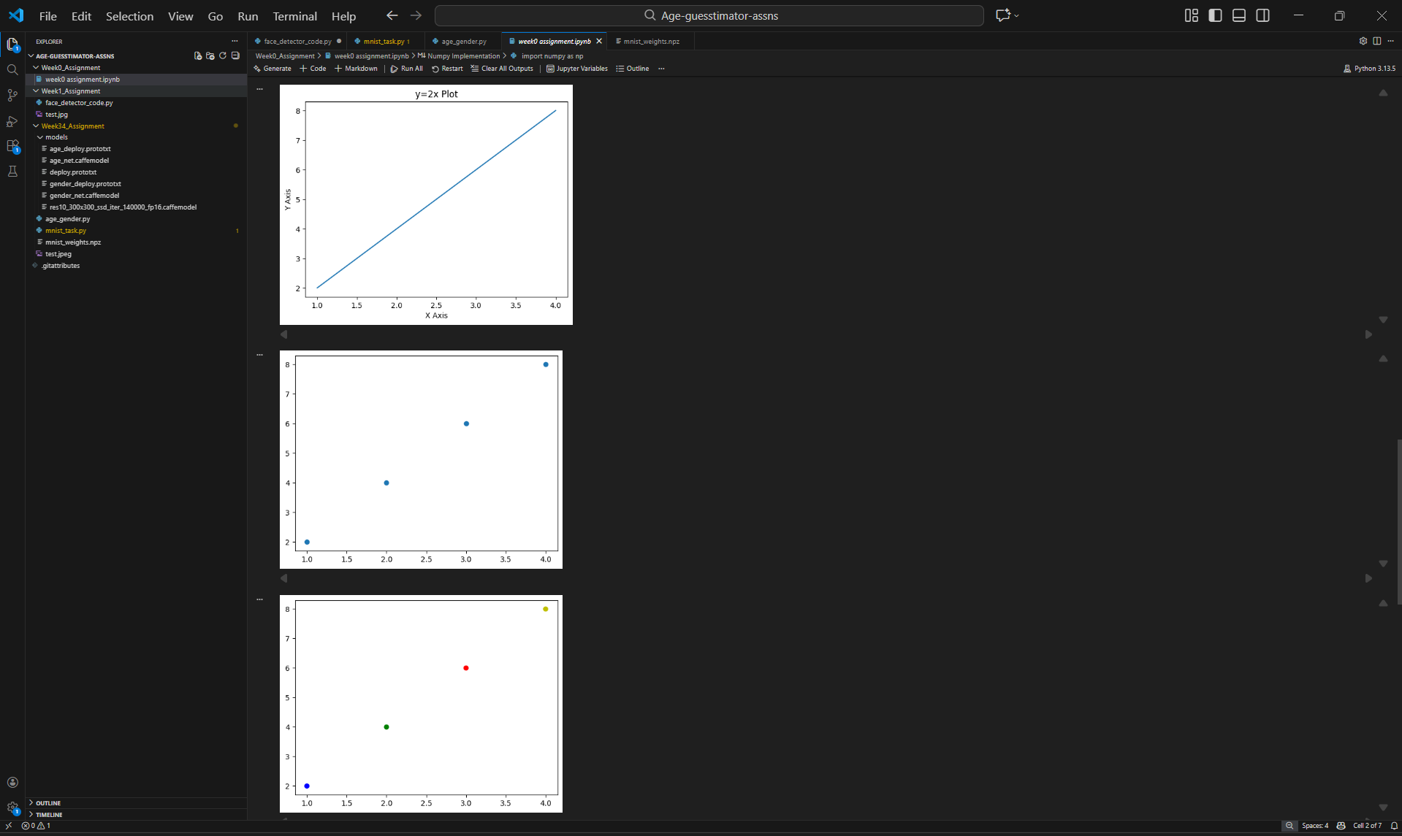
Image 1: Plotting the same data in different ways using matplotlib (this is only a part of the entire coding activity)
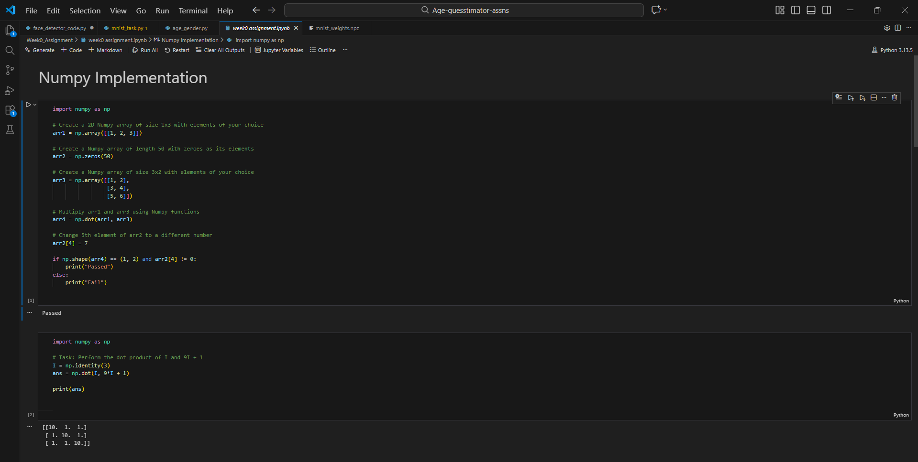
Image 2: Implementing Numpy Library.
Week 1: Introduction to OpenCV, Face Detection and Haar Cascades
In Week 1, I started learning about OpenCV, which is used for image processing and computer vision. This was my first proper exposure to working with images programmatically, so it was a new and interesting experience. I learned how to read images using OpenCV, display them, and understand how images are stored as matrices of pixel values, how to convert images to grayscale and why grayscale images are better as compared to coloured ones for analysis.
A major focus of this week was face-detection. I learned about Haar Cascade classifiers, how they work by identifying certain patterns in an image, such as edges and contrasts, and then using these patterns to decide whether a face is present.
We were given a YouTube video link to watch and learn OpenCV and Haar Cascade classifiers and it made a lot of sense; why we make rectangular divisions to compare intensities, how it makes stuff easier, the other ways we can do that and why Haar is the most basic yet most useful theory to compare intensities and identify faces.
For the Week 1 assignment, I had to write a Python script that actually detects faces in an image. We used a pre-trained Haar Cascade model that OpenCV provides (thank god we didn't have to train it ourselves!). The script had to load an image, convert it to grayscale, run the face detection on it, and then draw rectangles around any faces it found.
Okay, so this assignment... it gave me some trouble. I kept getting errors about the Haar Cascade file not being found. I'd put the file path in my code, but it kept saying it couldn't find it. Turns out I was using the wrong type of slashes in the path (Python prefers forward slashes). The most satisfying moment was when I finally ran the script successfully and saw blue boxes appear around the faces in the input image. Seeing the code actually work on real images made the learning experience very exciting!
I also learnt how to make a GitHub repository (to submit the Week 0 and Week 1 assignments), worked around with ‘commit’, ‘push’, etc. and also lost the fear that I had of not knowing my way around GitHub!
Implementing the face detector script was the defining moment of Week 1, as it marked my first transition from theoretical concepts to a functional computer vision application. The process involved orchestrating several moving parts, starting with loading the image using OpenCV and then converting it to grayscale to optimize the processing speed. The real challenge lay in tuning the detection function, specifically adjusting the parameters to ensure the model was sensitive enough to detect faces in various lighting conditions without producing false results.
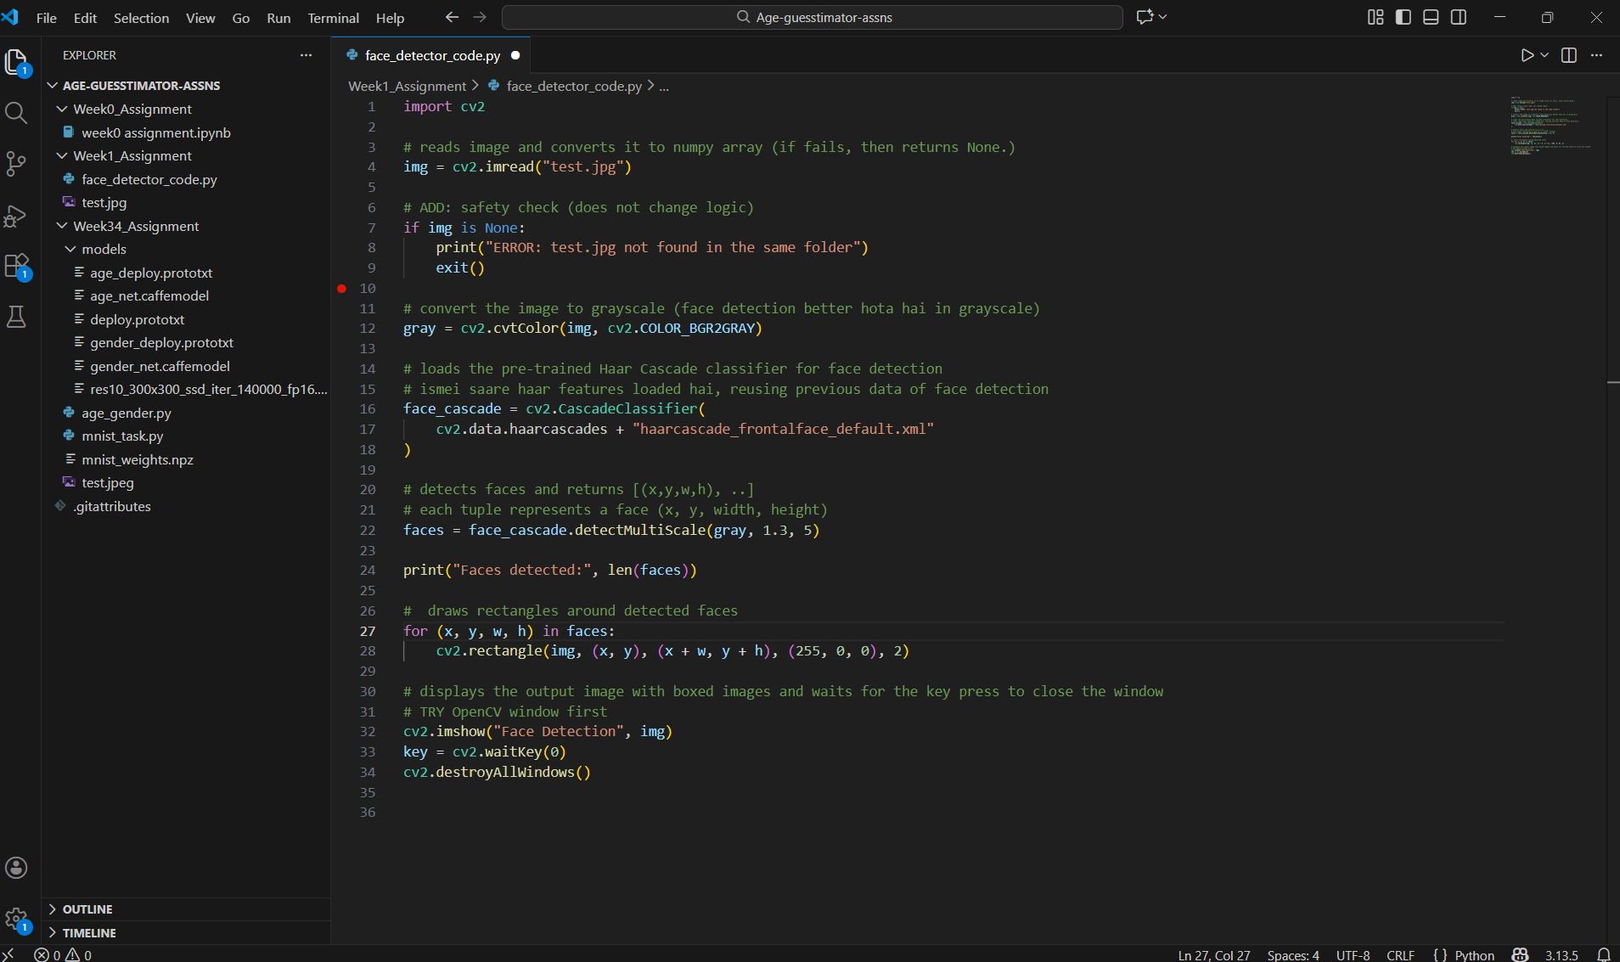
Image 3: Face-detector Code. (this doesn’t guess the age or gender, just detects the position of the face in the input image)
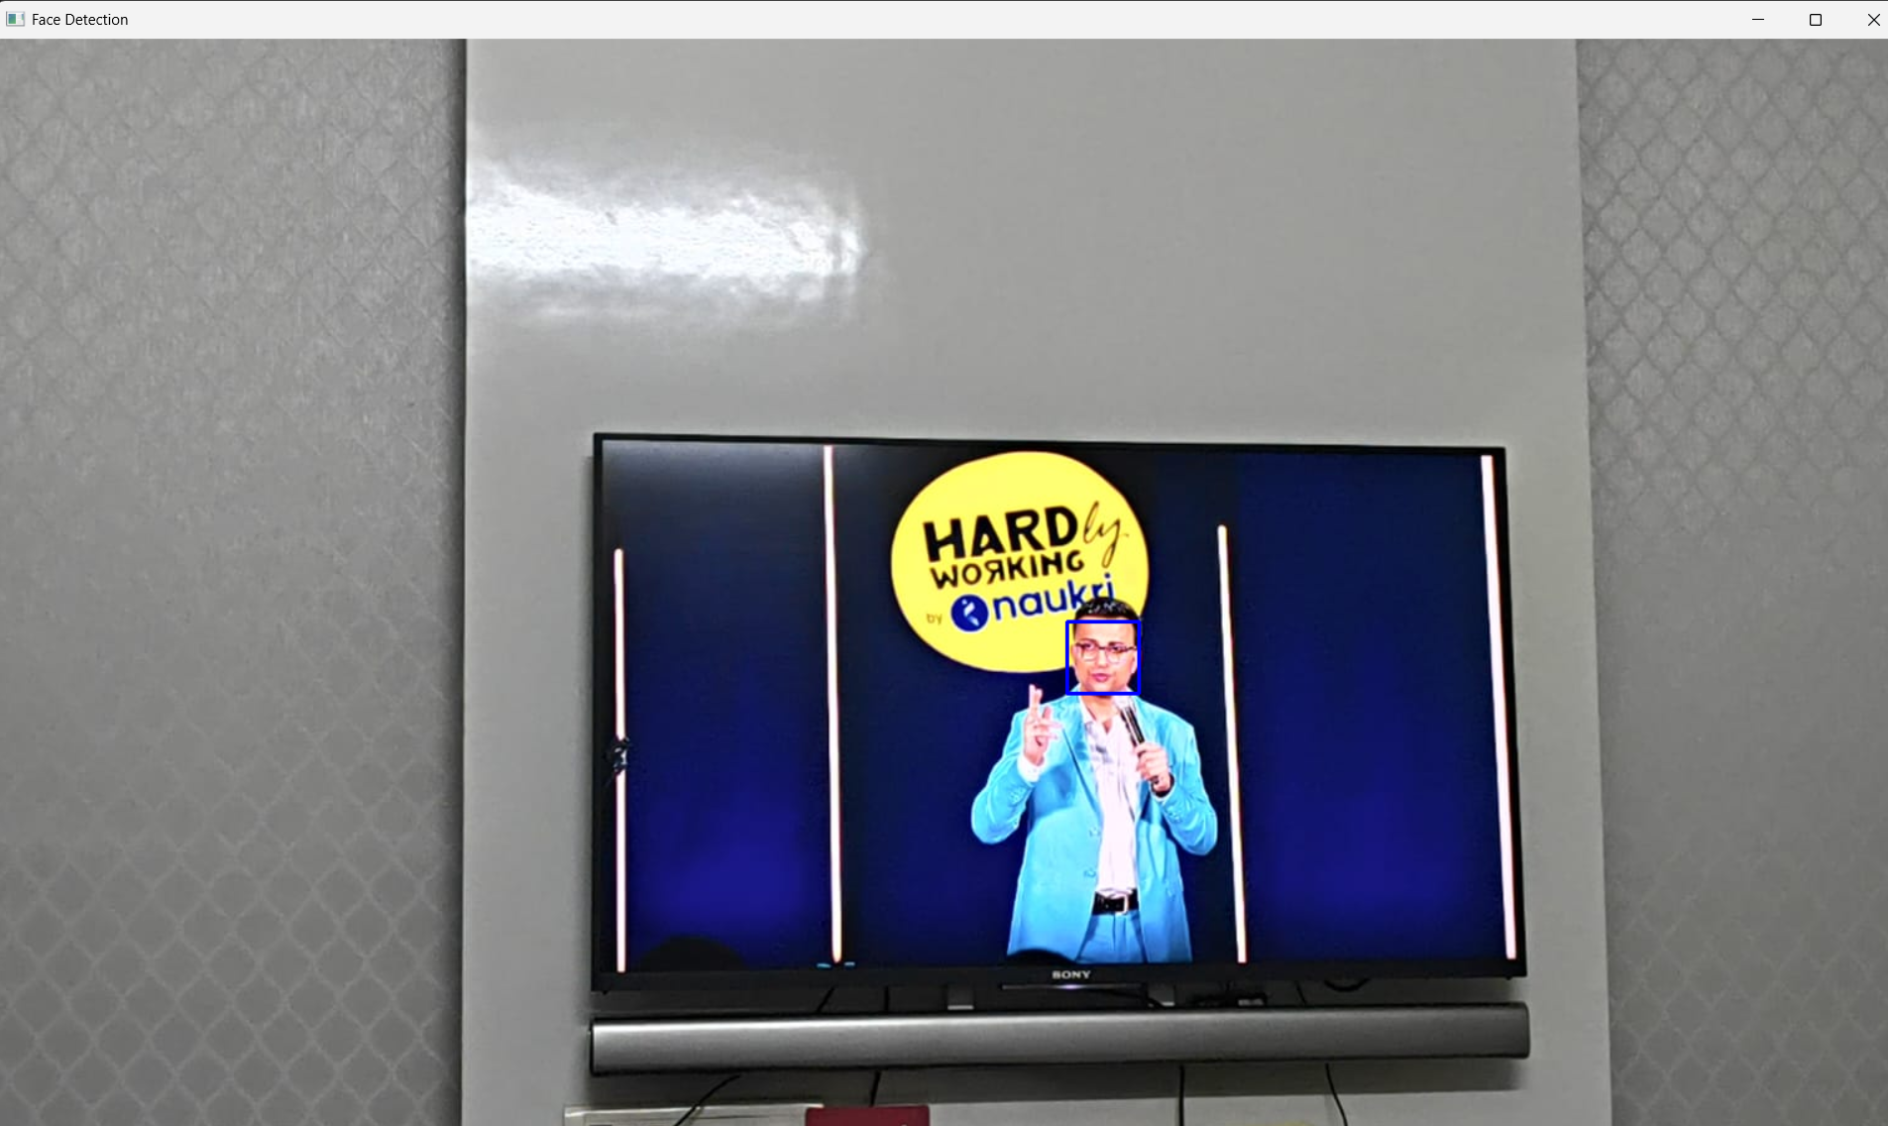
Image 4: The final output image, the face is detected by a small blue rectangle around it.

Week 2: Understanding Neural Networks and CNNs
Week 2 was heavy on theory, especially about neural networks and convolutional neural networks, which are basically the foundation of any age estimation model. Even though this week was mostly about reading and watching lectures rather than writing code (which seemed boring), it turned out to be one of the most important weeks for building a strong conceptual understanding of how these models actually work behind the scenes.
I started by learning the basics of neural networks from the book Neural Networks and Deep Learning by Michael Nielsen. This helped me understand what artificial neurons are and how they function as simple computational units. I learned how neurons take inputs, multiply them by weights, add a bias term, and then pass the result through an activation function.
I also learned how neural networks learn using gradient descent and backpropagation. Gradient descent helped me understand the idea of minimizing error step by step, rather than reaching the correct solution all at once. Backpropagation explained how the model calculates how much each weight and bias contributed to the final error and then updates them accordingly. Initially, the idea of forward propagation followed by backward propagation was a bit hard to truly “feel”, but as I read on, it started making more sense.
Understanding gradient descent helped me see how models slowly improve over time by learning from their mistakes and adjusting parameters in small steps. Back propagation was definitely the trickiest part conceptually, but it gave me a much clearer picture of how errors are propagated backwards through the network. This made me realize that training a neural network is not magic, but a structured and systematic process based on mathematics and optimization.
After covering basic neural networks, I moved on to learning about convolutional neural networks by watching video lectures. I learned why CNNs are particularly well suited for image related tasks compared to regular fully connected networks. I understood how convolution layers use filters that slide over an image to extract important features such as edges, textures, and simple shapes in the initial layers, and more complex patterns in deeper layers.
Even though I have not built a full CNN model yet, I now have a clear mental picture of how an age estimation model would work internally. I understand the full flow, starting from taking a raw image as input, processing it through multiple convolution and pooling layers to extract meaningful features, and finally passing it through fully connected layers to make a prediction. This theoretical knowledge is going to be extremely useful when we actually start training, testing, and evaluating models in Week 3 and Week 4.
(not attaching images as this was just a reading assignment!!)
Week 3: Building a Neural Network from Scratch
Week 3 was undoubtedly the most intellectually demanding phase of the entire WiDS program. The transition from using high-level libraries to implementing a neural network using nothing but NumPy felt like taking the training wheels off a bicycle. The primary objective was to build a digit classifier for the MNIST dataset, which contains 70,000 grayscale images of handwritten numbers. This task forced me to move past conceptual understanding and into the granular details of how data actually flows through a machine learning model.
I started by tackling the data representation problem. Each MNIST image is a 28x28 pixel grid, which I had to flatten into a 784-element vector. This vector served as the input layer for my network. The architecture I designed consisted of a hidden layer with ten neurons and an output layer of ten neurons, representing the digits 0 through 9. The real magic, however, happened in the mathematical functions. I implemented the ReLU (Rectified Linear Unit) activation function for the hidden layer because of its efficiency in preventing the vanishing gradient problem.
The implementation of Backpropagation was where I spent the majority of my time. It required a deep dive into calculus to understand how the model calculates the Loss, which is the difference between its guess and the actual label, and then works backward to find the gradient for every weight and bias. By applying the Chain Rule, the model could figure out exactly how much it needed to adjust its internal parameters to perform better in the next round. I also had to implement One-Hot Encoding, a process that converts categorical labels into binary vectors, ensuring the model treats the digit 9 as a different category rather than just a number that is bigger than 1. Watching the training accuracy in my terminal climb from a random 10% to over 90% was an incredibly satisfying validation that my math and code were finally in sync.
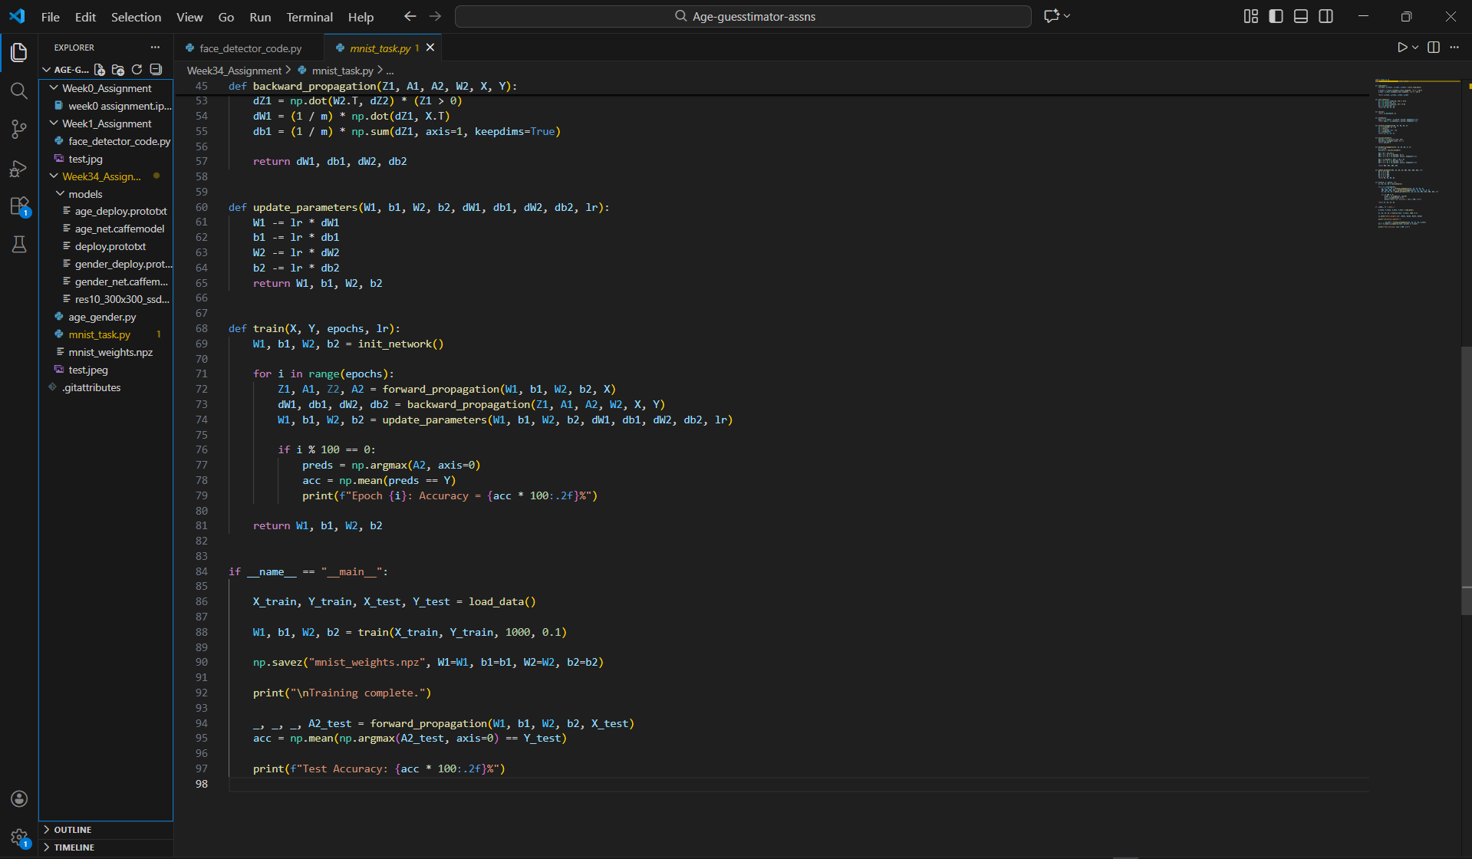
Image 5: A 100-liner code for creating the neural network..
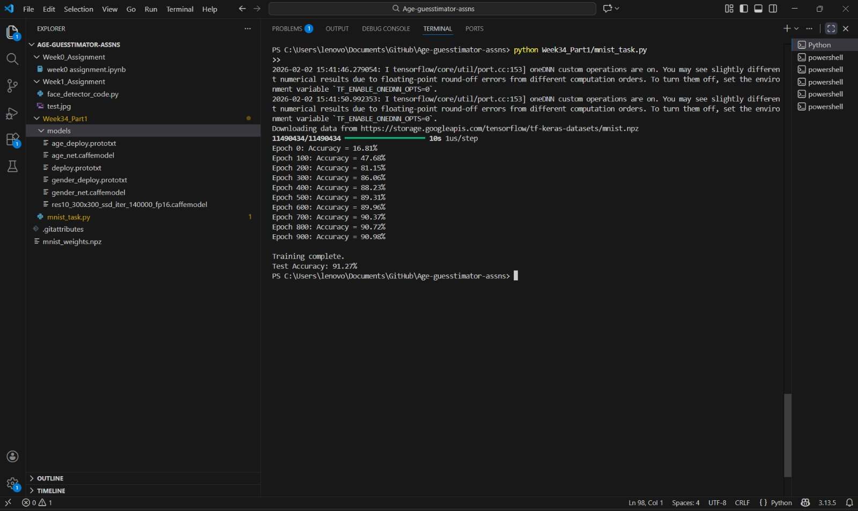
Image 6: Finally the neural-network giving an accuracy of 91.27%!!
Week 4: Final Integration and Demographic Inference
In the final week of the program, I moved from the theoretical world of scratch-built models to the practical world of demographic inference. The goal was to build a system that could identify a person's age and gender from a single image. Because training a face recognition model from scratch would require massive datasets and weeks of computing power, I utilized pre-trained Caffe models. This introduced me to the professional side of AI deployment, where we work with .prototxt files to define the skeleton of the network and .caffemodel files to load the millions of pre-calculated weights.
The integration process was a multi-stage pipeline that required careful coordination. The first step was using a ResNet-SSD model to locate any faces within an image. This specific detector is significantly more robust than the Haar Cascades I used in Week 1 because it uses a deep learning approach to handle variations in facial orientation, lighting, and occlusion. Once a face was detected, the script had to crop that specific region and transform it into a blob. I learned that a blob is a standardized format that includes spatial scaling and mean subtraction, which ensures the input image matches the exact distribution of the data the model was originally trained on.
The gender model would then classify the face as Male or Female based on the features extracted during the forward pass. Simultaneously, the age model would predict a range, such as (15, 20) or (25, 32). I learned that predicting an exact age is statistically difficult from a static photo because of individual biological variations, which is why grouping them into buckets is the standard industry practice. This probabilistic approach makes the system more reliable for real-world applications where exact precision is less important than general demographic trends.
The most frustrating yet educational part of this week was managing the project's environment and file hierarchy. I spent a good portion of time debugging path-related errors, realizing that Python’s os.path module is essential for making code that runs reliably on different computers. I also had to handle a library conflict where the standard mnist package was interfering with the get-mnist function I needed. This required me to clean my site-packages and rebuild the environment to ensure no naming collisions occurred between the two different libraries.
Solving these real-world bugs taught me that being a good AI developer is just as much about system management and debugging as it is about writing algorithms. I spent hours analyzing terminal logs and tracing file paths to understand why the OpenCV dnn module was failing to open the prototxt files. This process demystified the "deployment" phase of machine learning, showing me that even the best models are useless if the surrounding software infrastructure is not solid. Successfully running the final script and seeing a live image perfectly labeled with a person's age and gender was a fantastic conclusion to the project.
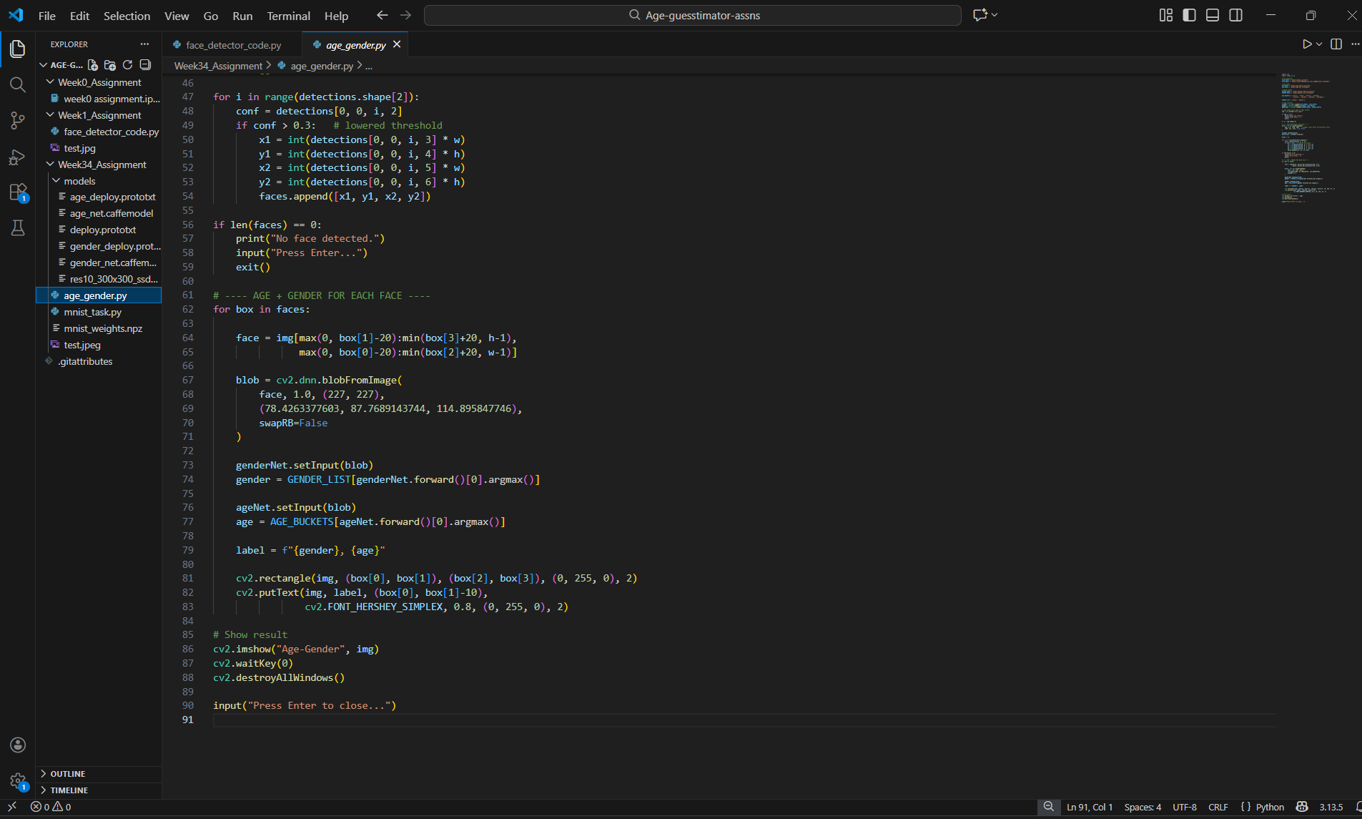
Image 7: A 90-liner code to guess the age and gender of the person (s) in the test image.
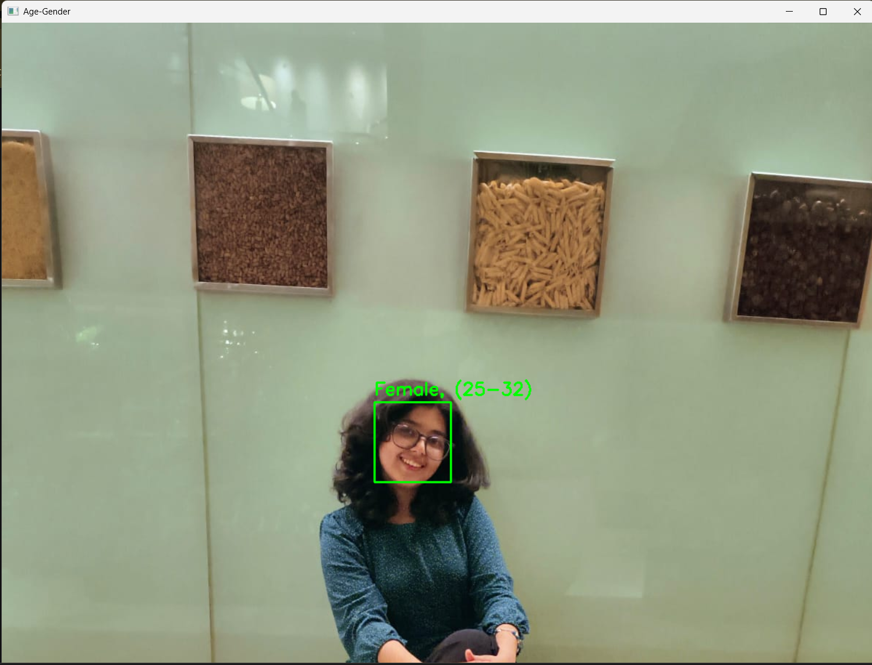
Image 8: The detected face, gender and age by my code.
Conclusion:
Through this WiDS project, I gained hands-on experience in building and understanding machine learning models from scratch as well as using pre-trained deep learning networks. In the first part, I implemented a neural network to classify handwritten digits using the MNIST dataset, which helped me understand forward propagation, backpropagation, weight updates, and model evaluation. In the second part, I worked with OpenCV and pretrained CNN models to detect faces and predict age and gender from images. This exposed me to practical computer vision pipelines and showed how trained models can be applied directly for real-world tasks.
The project also helped me understand important challenges such as data quality, model accuracy, and prediction uncertainty, especially in age estimation. Overall, this project strengthened my foundation in neural networks and computer vision while giving me valuable experience in debugging, integrating multiple libraries, and building complete ML workflows. It was a great learning experience that improved both my technical skills and my understanding of how machine learning systems are developed and deployed.

